Week 9 - Day 1 (Chapter 7 pt 2)
Table of Contents

CH101-008 UA Fall 2016
About

Week 9 - Day 1 (Chapter 7 pt 2)
Oct 10, 2016
Quizlet
Download Word (docx):

Navigate using audio

Announcements
- Audio 0:00:14.957544
- Student Affiliates of the American Chemical Society

Unhybridized Carbon Orbitals in CH4: Predict the Wrong Bonding and Geometry
- Audio 0:01:26.977877
- 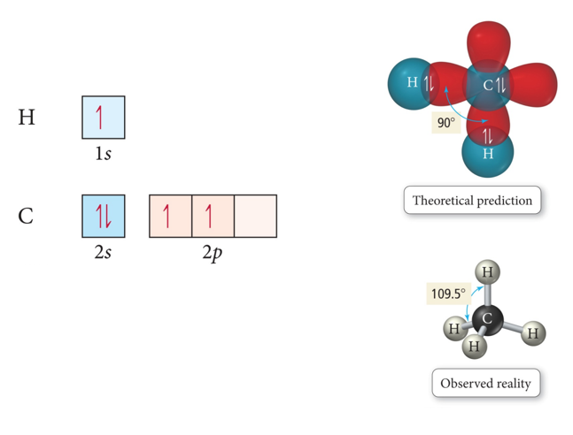

Valence Bond Theory and Hybridization CH4
- One of the issues that arises is that the number of partially filled or empty atomic orbitals did not predict the number of bonds or orientation of bonds.
  - C = 2s^2 2px^1 2py^1 2pz^0 would predict two or three bonds that are 90° apart, rather than four bonds that are 109.5° apart.
- To adjust for these inconsistencies, it was postulated that the valence atomic orbitals could hybridize before bonding took place.
  - One hybridization of C is to mix all the 2s and 2p orbitals to get four orbitals that point at the corners of a tetrahedron.

Hybridization
- Audio 0:02:36.629512
- Some atoms hybridize their orbitals to maximize bonding.
  - More bonds = more full orbitals = more stability
- Hybridizing is mixing different types of orbitals in the valence shell to make a new set of degenerate orbitals.
  - sp, sp2 , sp3 , sp3d, sp3d2
    - Four Hybrid orbitals
- The same type of atom can have different types of hybridization.
  - C = sp, sp2 , sp3
- 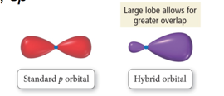
  - If we need a trigonal planar
    - Hybridize s and sp2

Hybrid Orbitals
- Audio 0:04:49.597515
- The number of standard atomic orbitals combined = the number of hybrid orbitals formed.
  - Example for carbon:
    - Combining a 2s with a 3p gives four sp3 hybrid orbitals.
  - H cannot hybridize.
    - Its valence shell only has one orbital.
      - 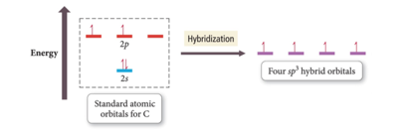
      - Audio 0:05:51.042164
- The number and type of standard atomic orbitals combined determines the shape of the hybrid orbitals.
- The particular kind of hybridization that occurs is the one that yields the lowest overall energy for the molecule.
- Audio 0:06:49.243321
- 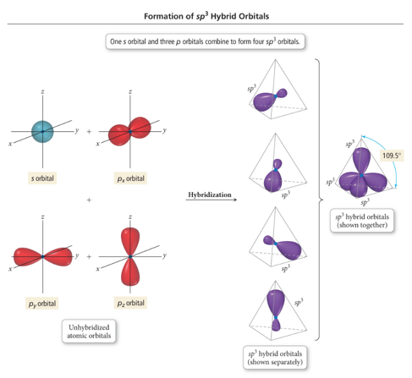
  - Take the s and 3 p orbitals and make four sp3 orbitals
    - Makes the tetrahedral geometry

sp3 Hybridization
- Audio 0:08:30.906596
- Atom with four electron groups around it:
  - Tetrahedral geometry
  - 109.5° angles between hybrid orbitals
- Atom uses hybrid orbitals for all bonds and lone pairs
- 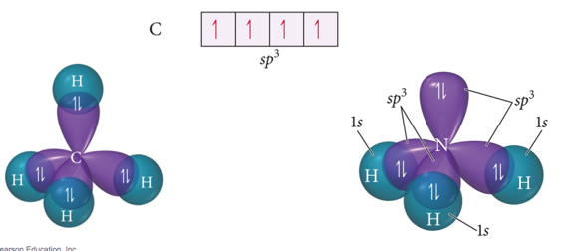
- Audio 0:08:43.856308

Formation of sp Hybrid Orbitals
- 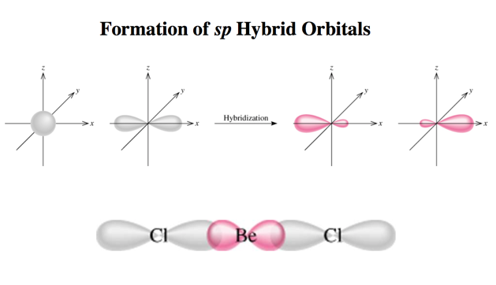

Formation of sp2 Hybrid Orbitals
- Audio 0:09:19.885131
- 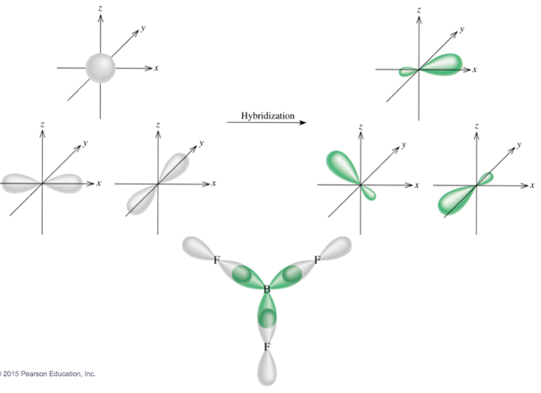

Clicker 1
- Audio 0:09:46.537377
- Give the electron geometry (eg), molecular geometry (mg), and hybridization for H2O
  - A) eg = tetrahedral, mg = bent, sp3
  - B) eg = trigonal pyramidal, mg = trigonal pyramidal, sp3
  - C) eg = tetrahedral, mg = trigonal pyramidal, sp3
  - D) eg = bent, mg = bent, sp3
  - E) eg = trigonal planar, gm = trigonal planar, sp3
A

sp3d Hybridized Orbital
- Audio 0:13:35.100695
- Atom with five electron groups around it:
  - Trigonal bipyramid electron geometry
  - Seesaw, T-shape, linear
  - 120° and 90° bond angles
- Use empty d orbitals from valence shell
- d orbitals—used to make π bonds
- 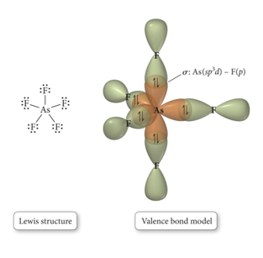

sp3d Hybridized Orbital
- 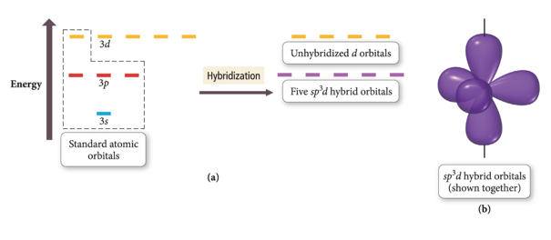

sp3d2
- Atom with six electron groups around it:
  - Octahedral electron geometry
  - Square pyramid, square planar
  - 90° bond angles
- Use empty d orbitals from valence shell to form hybrid
- d orbitals—used to make π bonds
- 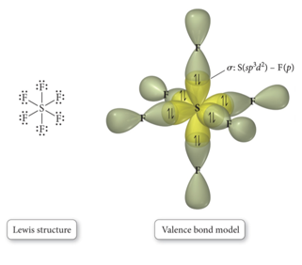

sp3d2
- 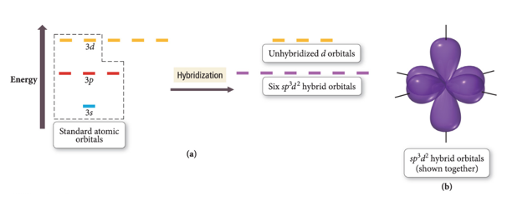
- 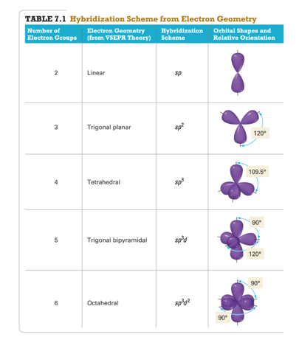

σ and π bonds:
- σ bonds –overlap along bond axis
- 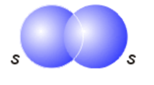

Hybridization: sp2
- Audio 0:19:16.146819
- Atom with three electron groups around it:
- Atom uses hybrid orbitals for σ bonds and lone pairs and uses nonhybridized p orbital for π bond
- 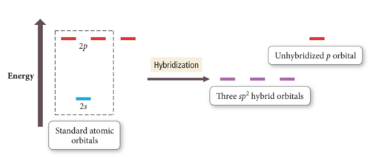
- 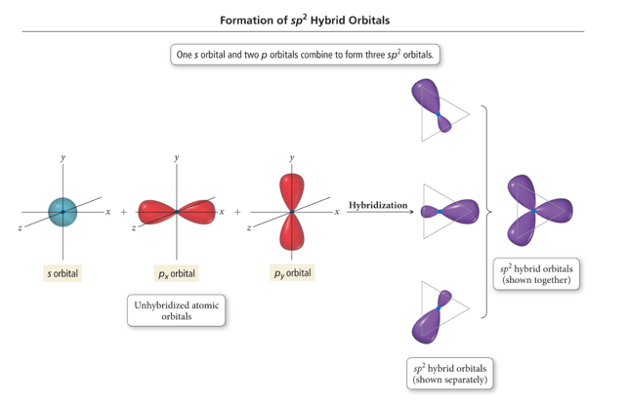

Sigma and Pi Bonding
- Audio 0:20:37.534711
- 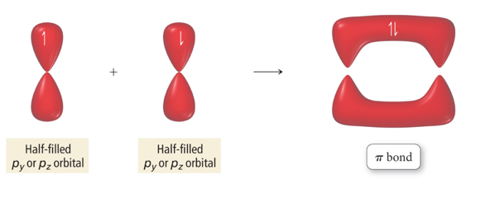

Orbital Diagrams of Bonding: H2CO
- Audio 0:21:03.253240
- 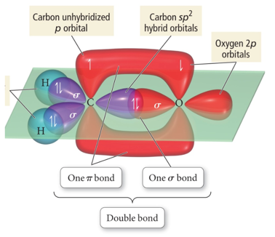
- “Overlap” between a sp2 hybrid orbital on C and s 1s orbital on H gives σ bond.
- “Overlap” between unhybridized p orbitals on C and O gives π bond.
- “Overlap” between C sp2 hybrid orbital and O sp2 gives σ bond

Types of Bonds
- Audio 0:24:50.789254
- A sigma (σ) bond results when the interacting atomic orbitals point along the axis connecting the two bonding nuclei.
  - Either standard atomic orbitals or hybrids
    - s to s, p to p, hybrid to hybrid, s to hybrid, etc.
- A pi (π) bond results when the bonding atomic orbitals are parallel to each other and perpendicular to the axis connecting the two bonding nuclei.
  - Between unhybridized parallel p orbitals
- The interaction between parallel orbitals is not as strong as between orbitals that point at each other; therefore, σ bonds are stronger than π bonds.

Bond Rotation
- Audio 0:26:21.602225
- Because of the orbitals that form the σ bond point along the internuclear axis, rotation around that bond does not require breaking the interaction between the orbitals.
- But the orbitals that form the π bond interact above and below the internuclear axis, so rotation around the axis requires the breaking of the interaction between the orbitals.
- 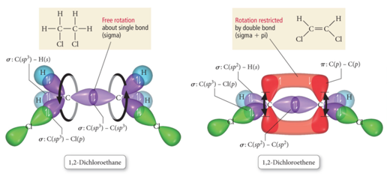
  - With a single bond, you have free rotation of the molecule around the bond
    - The rotation does not impact the strength of the bond
  - With a double bond, you’d have to break the bond to rotate
    - It actually freezes the structure of the molecule

Cis & Trans Isomers of 1,2-Dichloroethane
- Audio 0:28:53.696722
- 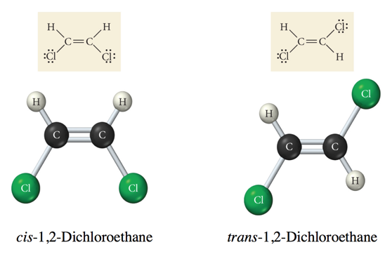
  - Same compound, different properties
  - Think about trans-fats
    - Still fat, but way more harmful

Clicker 2
- Audio 0:32:21.778478
- place the following in order of decreasing dipole moment
- I. cis-CHCl=CHCl II. trans-CHCl=CHCl III. cis-CHF=CHF
  - A) III > I > II
  - B) II > I > III
  - C) I > III > II
  - D) II > III > I
  - E) I = III > II
A. The trans dichloroethane actually cancels itself out and has 0 dipole moment. Then for the cis flourine, it has higher dipole moment than I, so A.

sp Hybridization and Triple Bonds
- Audio 0:35:28.142277
- Atom with two electron groups:
  - Linear shape
  - 180° bond angle
- Atom uses hybrid orbitals for σ bonds or lone pairs and uses nonhybridized p orbitals for π bonds
- 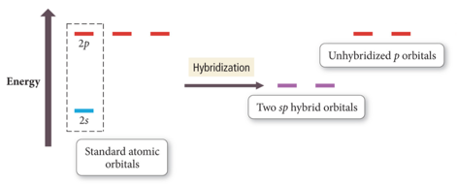

Formation of sp Hybrid Orbital in Ethyne
- Audio 0:36:27.515559
- 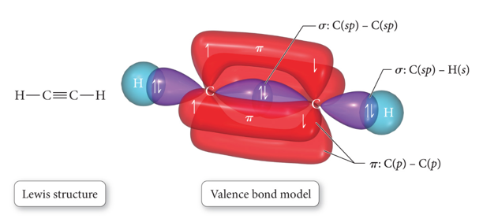

Predicting Hybridization and Bonding Scheme
- Audio 0:36:53.510663
  - Start by drawing the Lewis structure.
  - Use VSEPR theory to predict the electron group geometry around each central atom.
  - Use Table 7.1 to select the hybridization scheme that matches the electron group geometry.
  - Sketch the atomic and hybrid orbitals on the atoms in the molecule, showing overlap of the appropriate orbitals.
  - Label the bonds as σ or π.

Practice Problem on Hybridization Acetaldehyde: CH3CHO

Problems with Valence Bond (VB) Theory
- Audio 0:43:09.953460
- VB theory predicts many properties better than Lewis theory.
  - Bonding schemes, bond strengths, bond lengths, bond rigidity
- However, there are still many properties of molecules it doesn’t predict perfectly.
  - Magnetic behavior of O2
- Resonance hybrids: VB theory presumes the electrons are localized in orbitals on the atoms in the molecule, so doesn’t really address resonance structures
- Aka, we still have shortcomings
term | definition
hybridization | mixing different types of orbitals in the valence shell to make a new set of degenerate orbitals
sp2 hybridization | atom with three electron groups around it (uses nonhybridized p orbital for pi bond)
sigma (σ) bond | results when the interacting atomic orbitals point along the axis connecting the two bonding nuclei
pi bond | results when the bonding atomic orbitals are parallel to each other and perpendicular to the axis connecting the two bonding nuclei
sigma bonds are (stronger or weaker?) than pi bonds | stronger
Please enable JavaScript to view the comments powered by Disqus.

CH101-008 UA Fall 2016
- CH101-008 UA Fall 2016
- jmbeach1@crimson.ua.edu
- jmbeach
- hey_beach
Notes and study materials for The University of Alabama's Chemistry 101 course offered Fall 2016.

